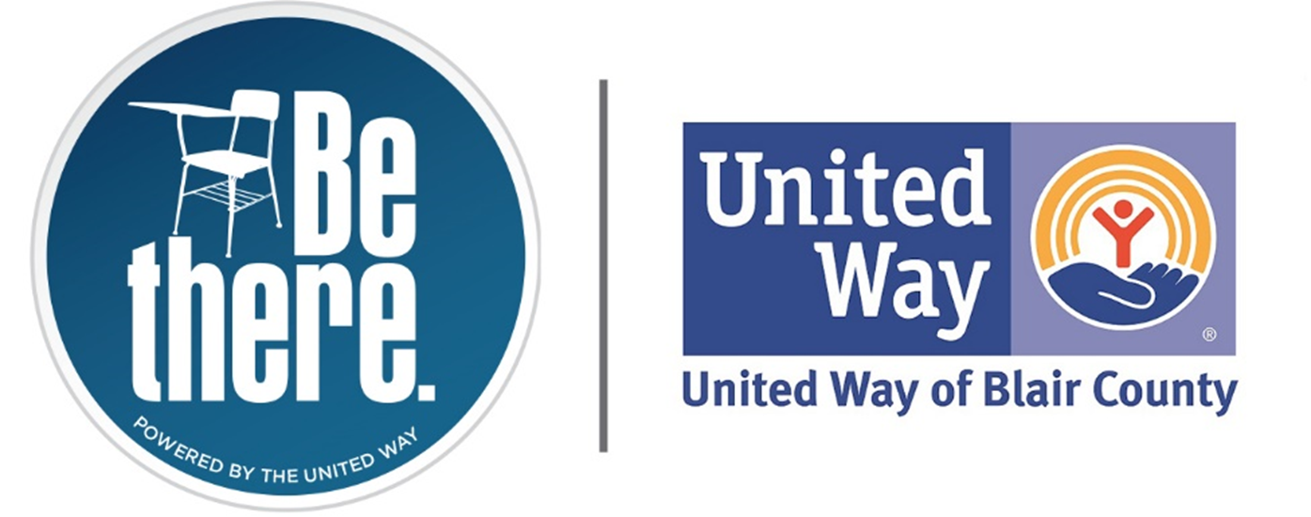

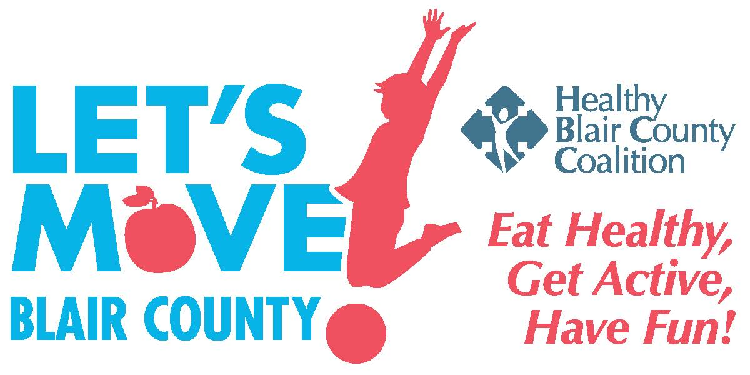
The Steering Committee for the
Healthy Blair County Coalition (HBCC)
Invite You to Attend a Meeting for an
Update on the Accomplishments, Future Activities, Plans for the Next Community Health Needs Assessment, and Sustainability of HBCC
Friday, September 29, 2023
Registration and Light Breakfast: 8:00 – 8:30 am
Presentation: 8:30 – 10:30 am
The First United Methodist Church (Social Hall)
801 Allegheny Street, Hollidaysburg, PA
The purpose of the meeting is to provide an update on the progress, accomplishments, and opportunities to become involved in future strategies and activities. Our work groups/ committees have been meeting to address the areas identified in the needs assessment and have made significant progress, including launching a new Let’s Move Into Kindness campaign. In addition, we will be planning our next community health needs assessment and will be seeking input on that effort. Finally, we are excited to share plans for the long-term future sustainability of HBCC.

As has been mentioned, the goal of the Healthy Blair County Coalition is to promote healthy living and well-being through community interventions that result in improvement of social, economic, and environmental factors. We encourage participants from all segments of the community to either continue your participation on the Coalition or join us in this effort. We continue to utilize the “collective impact” concept as we move forward in which a highly structured collaborative effort can achieve substantial impact on large scale social problems. Please come and share your efforts as well.

RSVP to Coleen Heim at info@healthyblaircountycoalition.org. There is no charge to attend. You may also contact her with questions about the Healthy Blair County Coalition at 814-317-5108 ext. 305 or visit our website at www.healthyblaircountycoalition.org. Please share this invitation with your colleagues and contacts.

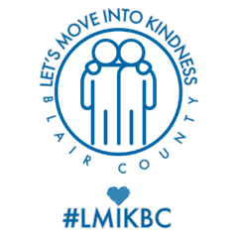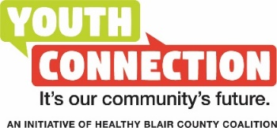

0

